**Lead Scoring Case Study**

**Data Quality checks and handling missing values:**

Data set were provided

* Leads Data

We have considered Leads data set and performed necessary actions as explained below.

**To find out the missing values and handle it :**

* After converting label ‘select’ into nan values. We will again check all the missing value.

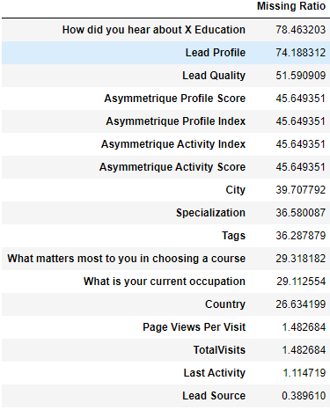

* And dropped all columns from data frame for which missing values % is more than 40.
* We will check the skewness which is very high and drop them also.

**Data Preparation:**

While understanding the data, we get to know that many categories with a very little percentage of rows, we combine into a new category name 'Other'. After cleaning, the retained percentage of rows is 58% of the rows.

**Data Visualization:**

**Total Time Spent on Website vs Page Views Per Visit**

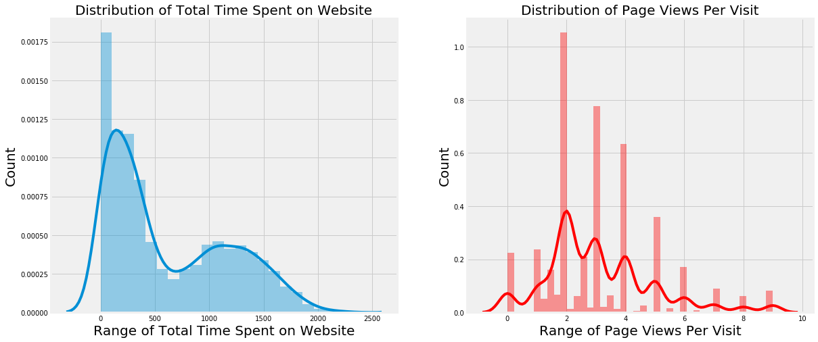

we can infer one thing that at max Page views per visit is 3.8 and total time spent on website is 0.12. Means 2000 Customer likely to spent time on website where as average number of page view per visit is 2.

**Tags**

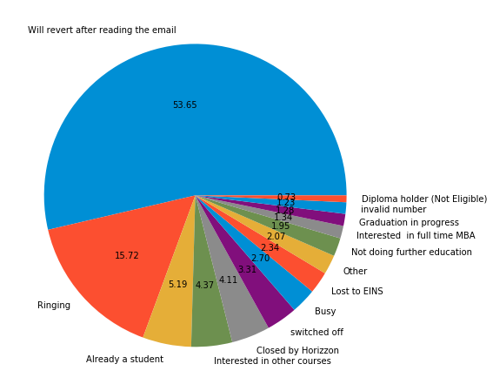 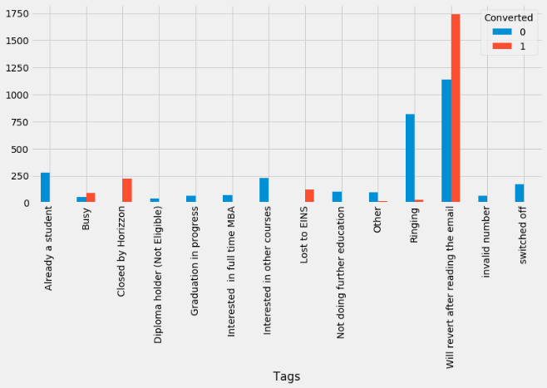

We can see that majority of customer in conversion process are 53.65% were those who will revert after reading the email and 15.72% of ringing. And also converted leads were high in will revert after reading the email

From this we can say closed by horizon and will revert after reading the email are our potential leads

**Last Activity**

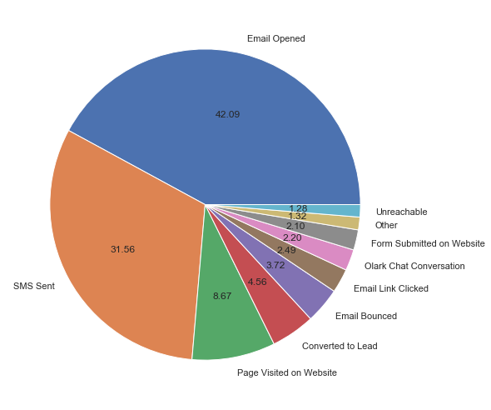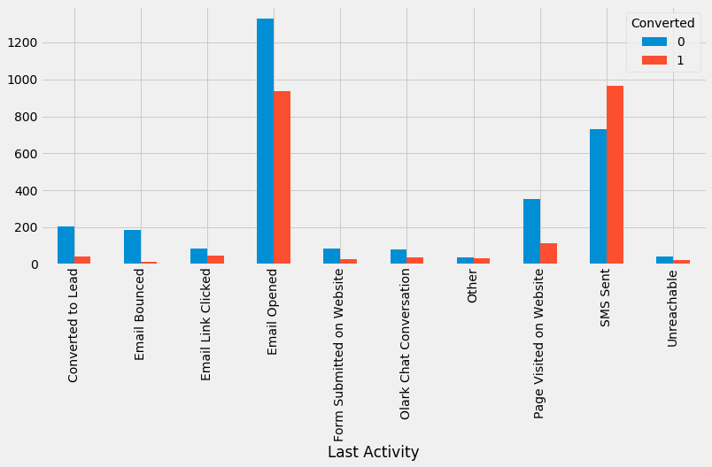

We see that majority of customer in conversion process are 42.09% were those who will open the email and 31.56% of sent through SMS.

Out of non-conversion lead, x-education able to achieved 950 conversion lead

We say SMS sent and open the email are our potential leads

**Specialization**

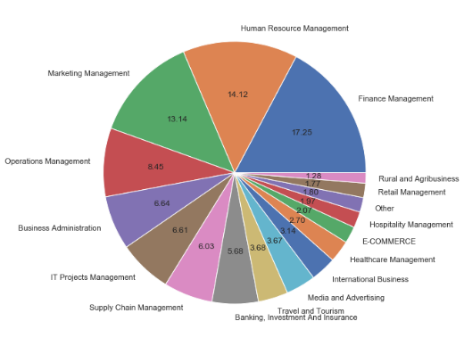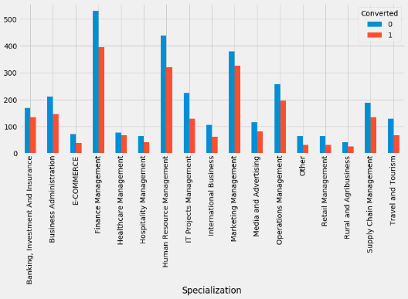

We see that majority of customer in conversion process are 17.25% were those who are in Finance Management, 14.12% of Human Resource Management and 13.14 of Marketing Management.

Out of non-conversion lead, x-education able to achieved 370 conversion lead

So, we say open the email and SMS sent are our potential leads

**What is your current occupation**

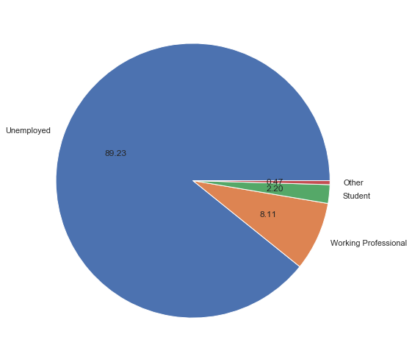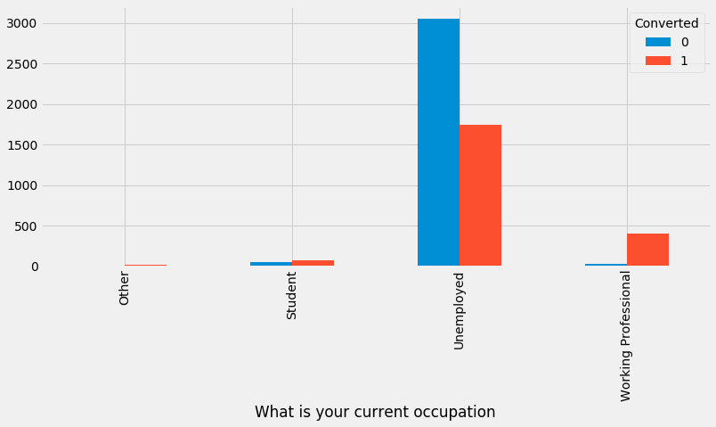

We see that majority of customer in conversion process are 89.23% were Unemployed and 8.11% of Working Professional. And highly conversion rate from Working Professional and some from student. And highly non-conversion rate from Unemployed but still x-education able to achieved the lead to convert from Unemployed around 1700.

Thus, Working Professional and student are our potential leads

**Last Notable Activity**

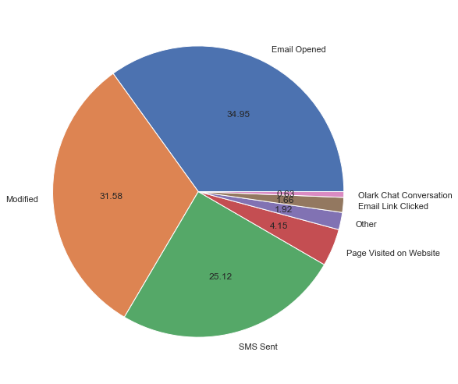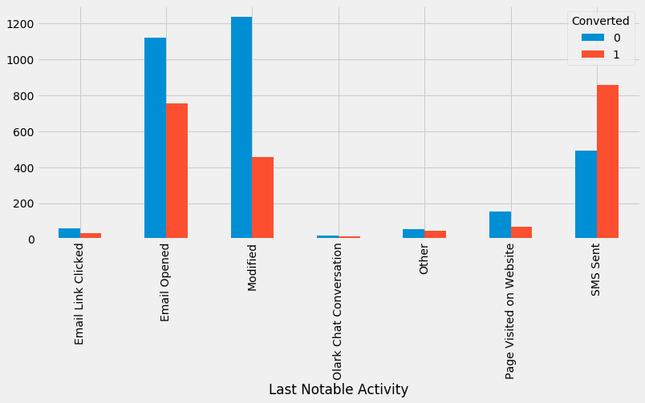

We see that majority of customer in conversion process are 34.95% were those who will open the email, 31.58% of modified and 25.12 through SMS Sent. Means those who check the SMS are our potential leads

**Lead Source**

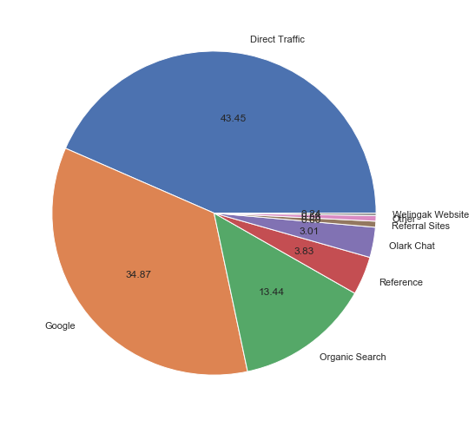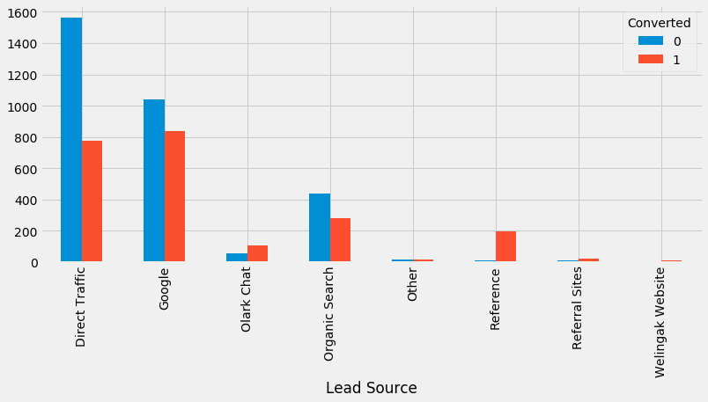

We see that majority of customer in conversion process were from 43.45% of direct traffic, 34.87% from Google and 13.44 from Organic Search

Therefore, most of the customers that are in reference are converted to full time and through Google also 830 is achieved

**City**

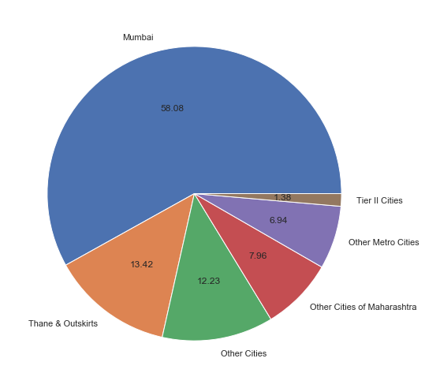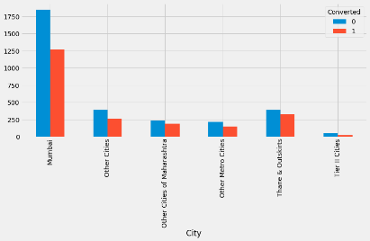

The majority of customer in conversion process were from 58.08% of Mumbai, 13.42% of Thane & Outskirts and 12.23% of Other Cities. Means most of the customers were from Maharashtra. Out of non-conversion rate, customer from Mumbai were able get converted up to 1255 and from Thane & Outskirts is 260

**Country**

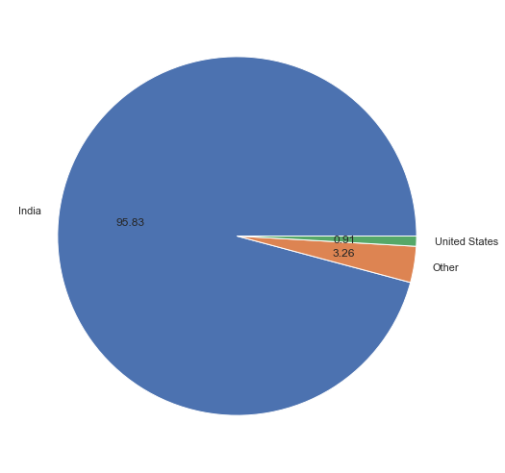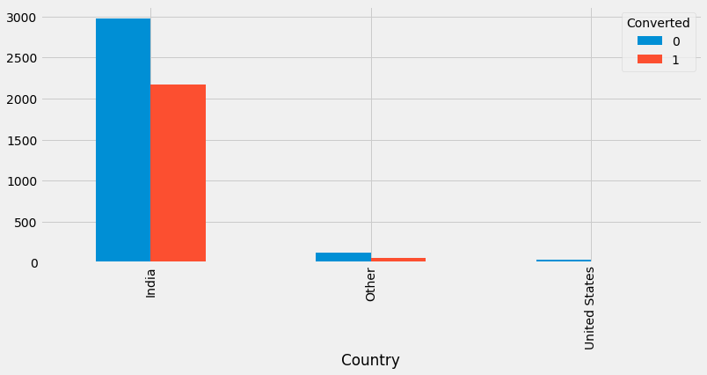

Definitely most of the customers were from India but 0.91% were from United States. X-Education targating customer more from India rather than others. And out of 95%, 80% is converted

**A free copy of Mastering the Interview**

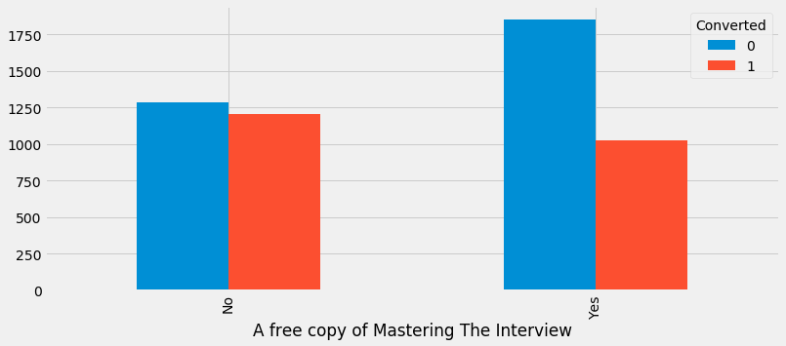

Most of the customers who wants a free copy of 'Mastering the Interview' has not converted into full time whereas most of the customers who don't want a free copy of 'Mastering the Interview' has nearly converted into full time

**Receive More Updates About Our Courses**

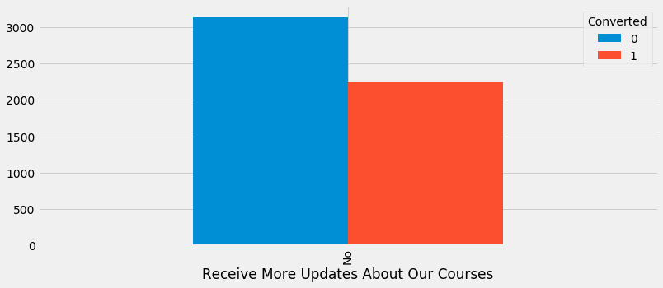

Those customers don’t want to choose to receive more updates about the courses were converted more into full time

**I agree to pay the amount through cheque**

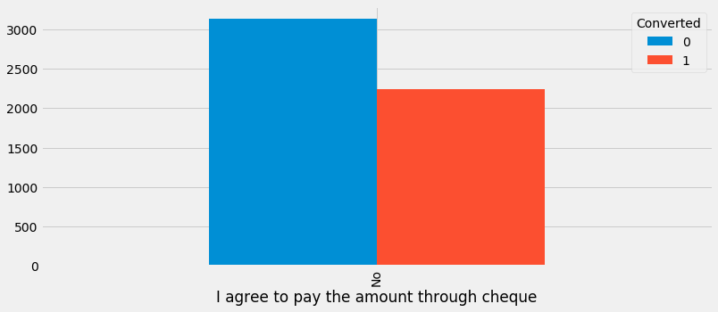

We clearly see, customers don’t want to pay the amount through cheque but preferred more digitally.

**What matters most to you in choosing a course**

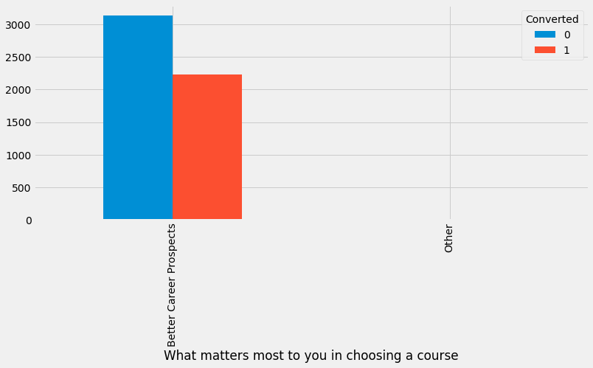

Of course, doing courses will be better for career prospects, still some of customer were not interested to convert

**Count Plot**

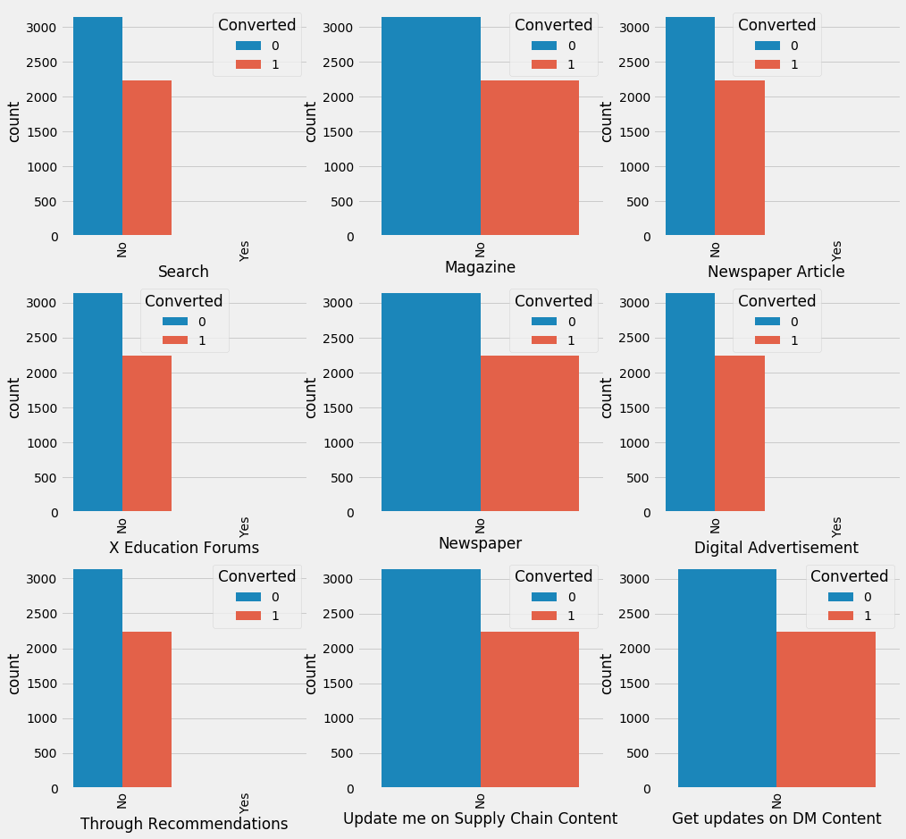

we can infer that most of them were in lower lead conversion. But out of lower lead still customers has been converted into full time up to 2000

**Pair Plot**

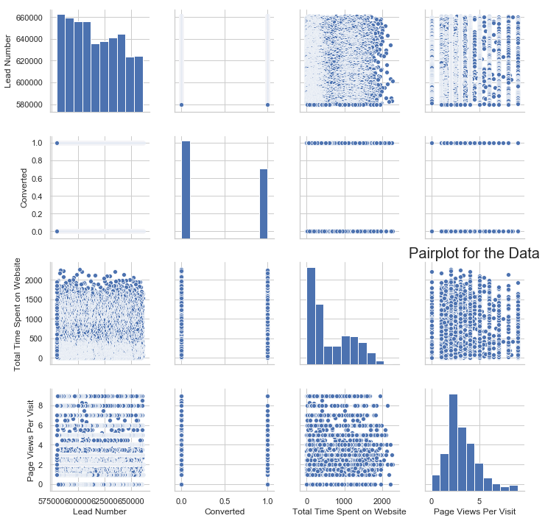

By pair plot we can able to see the pattern of highest correlation with the target variable

**Outlier Treatment**

**Analyzing and Interpreting *outlier through* Skewness Values *by pl*otting boxplot**

**Page Views Per Visit Column**

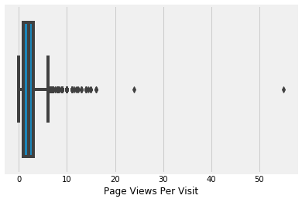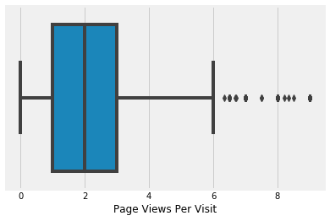

After Looking at the Box plot, it become clear that there are Outliers, and these outliers are important to be treated for a better predictive model. We do cap because if we drop them then we may lose students who want to converted.

So, skewness gets overcome (like in page views per visit column earlier skewness was 2.87132 and now it came down to 0.91362)

For now, we can leave those values as it is. And good to go

**Scaling:** Scaling is performed mostly during model building processes to bring everything to the same scale. Standardized scaling, on the other hand, brings all the data points in a normal distribution with mean zero and standard deviation one. It can improve the efficiency of model. So, it becomes an essential step before model building.

**Model Building**

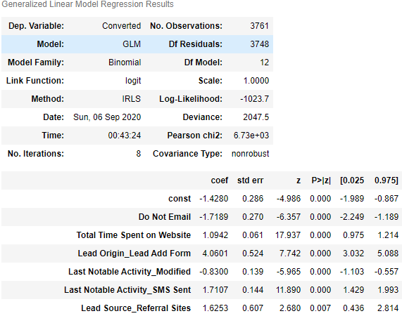

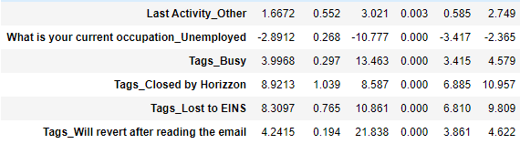

we use the recursive feature elimination technique to choose 25 variables, and using the manual approach we drop some variables based on p-value and VIF, and the final model we have 12 variables

## Let’s find out Number of Optimal cutoff point:

## 

At 0.4 accuracy, sensitivity and specificity are 0.893911, 0.895551 and 0.892760 almost equal

**Precision and Recall tradeoff**

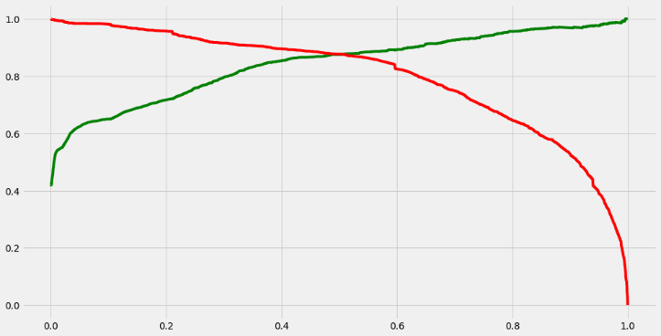

We get to see high recall/sensitivity and high precision. From this, we get to know that model is a very good means we don't have unwanted variables (noise) in our model.

**Plotting the ROC Curve**

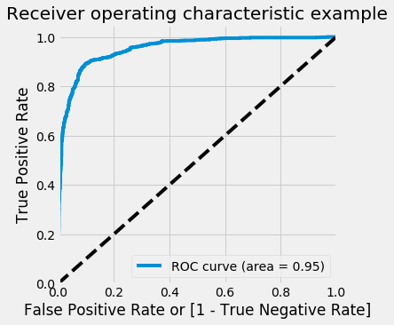

The above model says that there is a 95% chance that the model can distinguish between positive and negative class

**As per my Confusion Matrix, Classification Report is generated**

 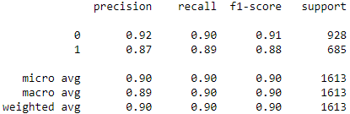

By optimal cutoff 0.4: class 0 (student not get converted) Sensitivity is 90%. And class 1 (student get converted) Sensitivity is 89%. Out of 1613 student only 685 students are able to converted into full time student. And rest 928 students are not converted into full time student.

**Conclusion**

So, from this analysis by sensitivity we can say that, probability of student getting converted into full time student is 89%.

On Training: sensitivity = 89.5% and precision = 85.4%

On Testing: sensitivity = 89% and precision = 86.9%

Which conclude Model is very good and can able to classify correctly.

As per business requirement, the potential leads are those on which at a certain threshold the recall/sensitivity more. And in the future also the company can handle the model smoothly by changing the threshold according to their requirements.

**A lead score between 0 and 100 to each of the leads which can be used by the company to target potential leads are:**

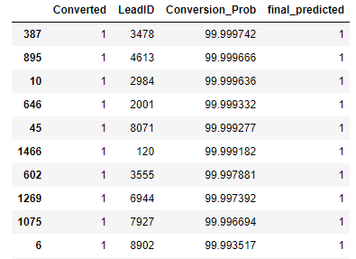

According to business requirement, we need to identify a higher score would mean that the lead is hot,i.e.is most likely to convert

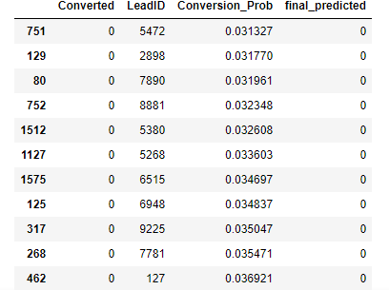

A lower score would mean that the lead is cold and will mostly not get converted